Week 9: Pipeline Creation using script
- Evaluation of Jenkins pipeline.
- WORKING ON BUILD TRIGGERS FOR LAST JENKINS PIPILINE
- Hands-on practice on creation of scripted Jenkins pipeline.
- Take the screenshots for above task

Procedure
General :
Description :- provide the description of the project
Build triggers: here we can provide with build triggers of you choice
Advance project option:
Definition:
Choose pipeline script

Here code for pipeline -script

Copy the code there
-------------------------------------------------------------------------------------------------------------------------
pipeline {
agent any
tools{
maven 'MAVEN-HOME'
}
stages {
stage('git repo & clean') {
steps {
//bat "rmdir /s /q mavenjava"
bat "git clone provide your github link"
bat "mvn clean -f mavenjava"
}
}
stage('install') {
steps {
bat "mvn install -f mavenjava" #project name#
}
}
stage('test') {
steps {
bat "mvn test -f mavenjava"
}
}
stage('package') {
steps {
bat "mvn package -f mavenjava"
}
}
}
}
Apply and save
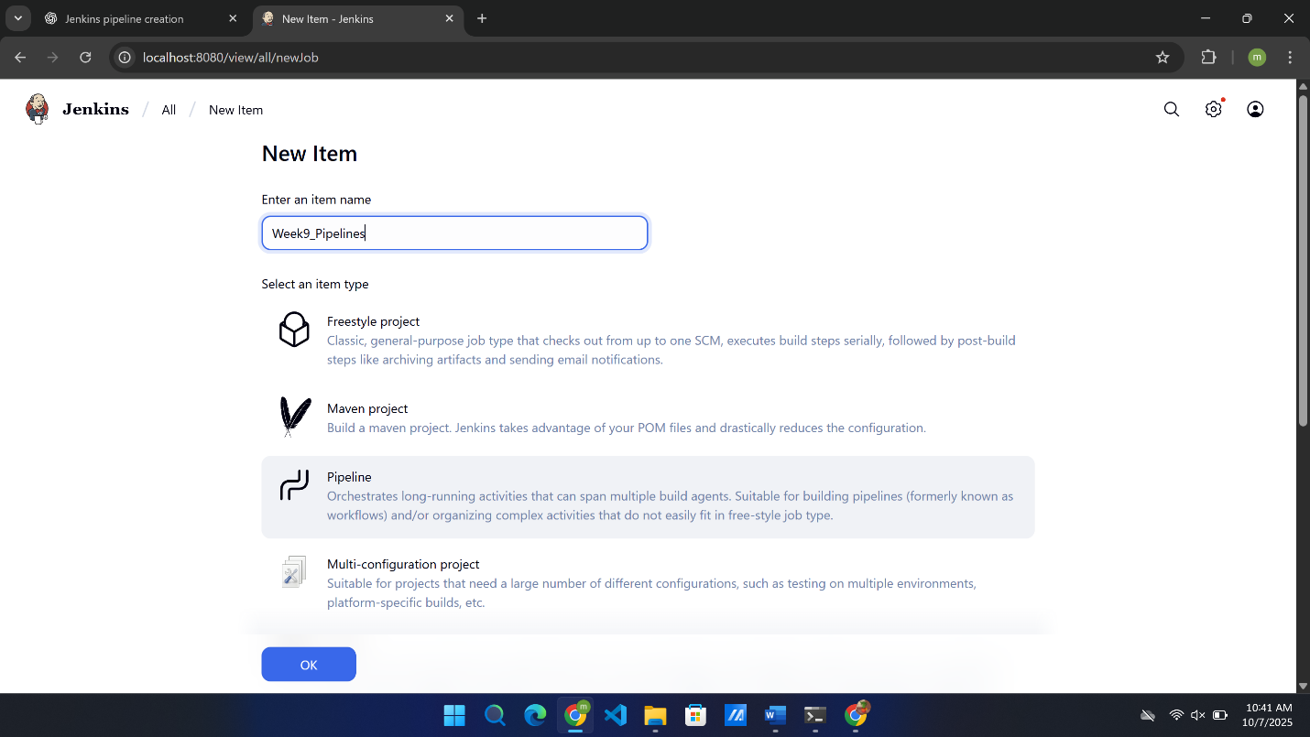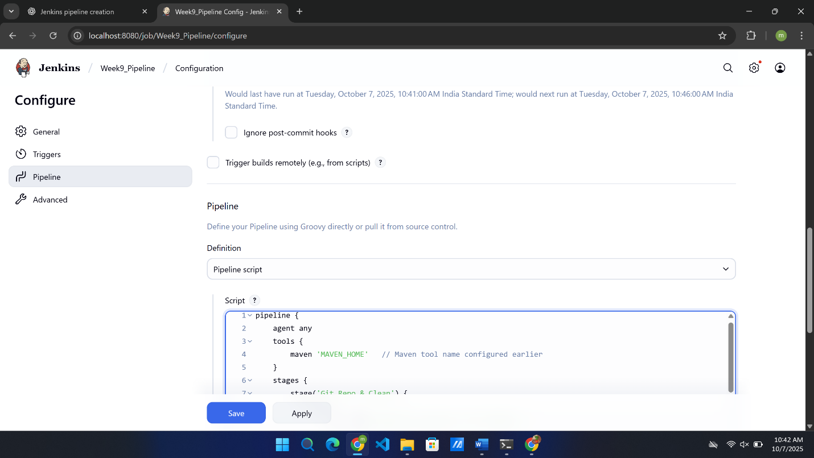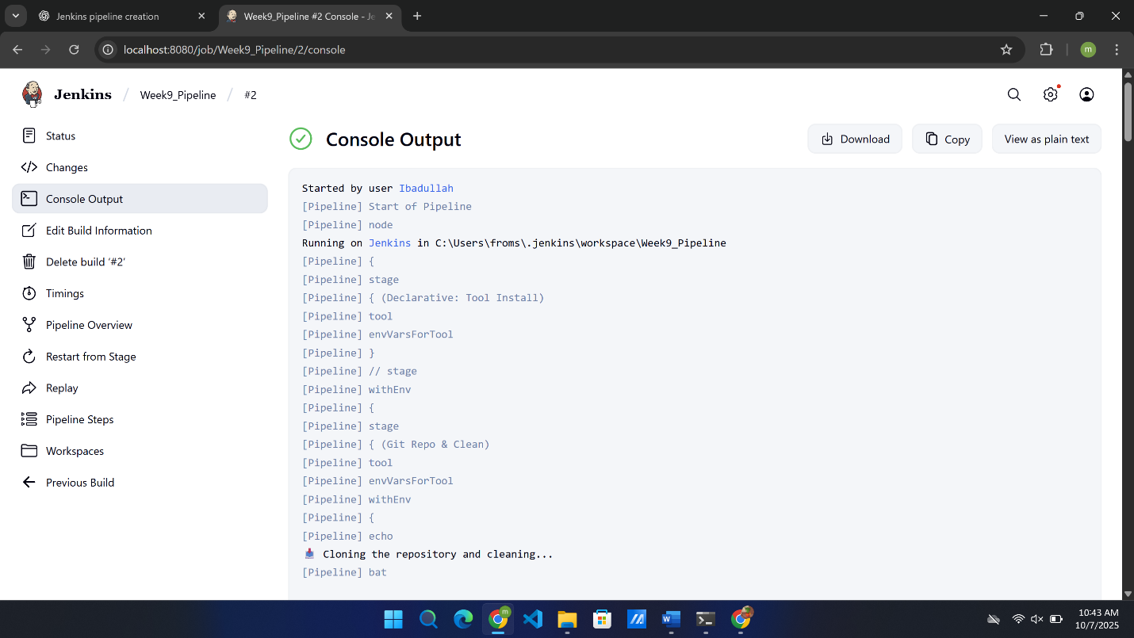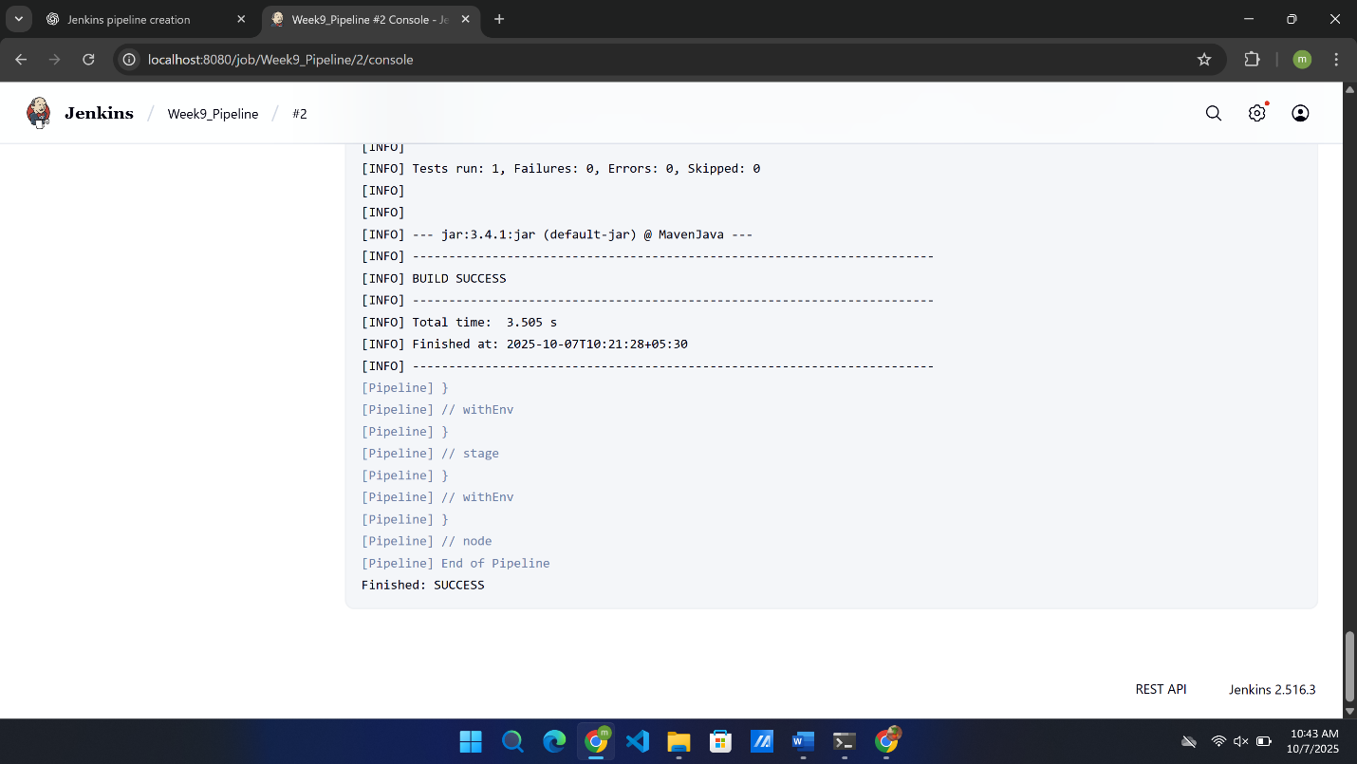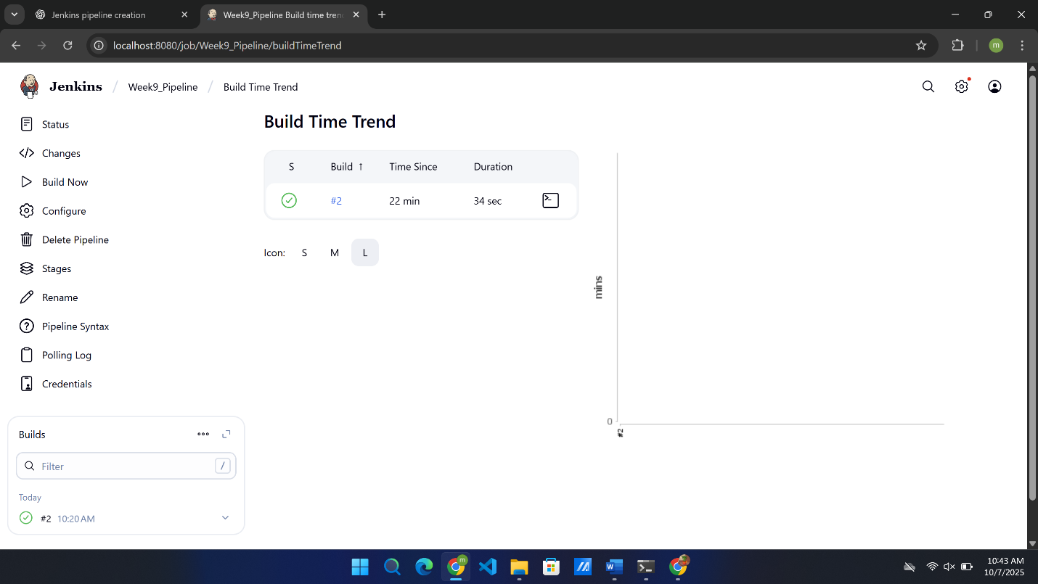
SBQ’s:
- Your manager asks you to clean the workspace before building — which stage in this pipeline takes care of it?
Ans . Git Repo and Clean stage
This stage cleans the old files and clones a fresh repo.
- The GitHub repository link is missing in the script — where exactly do you provide it?
Ans. Add it in the git clone command inside the git repo and clean stage.
- If Maven is not configured globally in Jenkins, which section of the pipeline will fail first?
Ans. The first stage of the pipeline will be failed.
- A teammate complains the pipeline is not creating .war files — which stage is responsible?
Ans. Package stage is responsible if not creating .war files because it runs mvn package.
- Your test cases failed, but the pipeline still continued — how will Jenkins behave in the test stage?
Ans. Jenkins still marked the stage as failed ,but next step continues until you set stop on failure.
- Instead of running nightly builds, you want this pipeline to trigger only when GitHub changes occur — where will you configure it?
Ans. Configure it in build triggers – GitHub hook trigger for GITScm polling.
- If you replace mvn clean with mvn compile, what difference will it make to the project build?
Ans. It won’t delete old files else it just compile the new code.
- The project folder name is not mavenjava but studentapp — which parts of the script must you edit?
Ans. Update all paths like – studentapp/pom.xml and the git clone line.
- If the install stage fails, will the test and package stages still run in this pipeline?
Ans. Test and package stage will not run if install stage fails because in a pipeline tasks are synchronous that runs one after the another.
- A student asks where to add deployment steps to Tomcat after packaging — which is the best place in this script?
Ans. After package stage add a new stage called deploy.
- Why is tools { maven 'MAVEN-HOME' } used in this pipeline?
Ans. Tools help the Jenkins to do the work. It tells the Jenkins about the version and where to find the path for that tool.
- If GitHub credentials are private, how can you secure them in the git repo & clean stage?
Ans. Use credentials in Jenkins and add it in the git stage : git credentialsId:’your_id’,url:’repo_url’.
- Which Jenkins plugin is needed to recognize the pipeline { ... } structure in this script?
Ans. Pipeline plugin(also called as declarative pipeline plugin).
- In Windows, the script uses bat commands — what change would you make if Jenkins runs on Linux?
Ans. Replace all bat commands with sh commands.
- How will you modify the pipeline to stop execution if the GitHub clone command fails?
Your project lead asks you to print a welcome message in Jenkins to confirm the pipeline is working — how would you script it?
Ans. Add || exit 1 after the clone command so pipeline stops on error.
Example: git clone https://... || exit 1
- A teammate forgot to pull the latest GitHub code before building; how can you fix this in your pipeline?
Ans. Git pull origin main
- Your Java file Hello.java must be compiled every time code is committed — how will you add this step?
Ans. Mvn compile -f mavenjava/pom.xml.
- Tests should stop the pipeline if they fail — where will you put the mvn test command?
Ans. Keep mvn test inside the Test stage,Jenkins stops automatically if test fails.
- Every evening at 6 PM your pipeline should run automatically — how can you set this in Jenkins?
Ans. Inside the build triggers schedule to H 18 * * *.
- You only want to package the project if compilation succeeds — how would you connect the stages?
Ans. Keep package stage after compile stage,Jenkins runs sequentially it won’t reach package if compilation fails.
- Your professor wants a .jar file generated for submission — what pipeline stage will you add?
Ans. Package stage added where mvn package builds the jar file.
- A Git clone step is failing due to wrong credentials — how would you secure and use them in your script?
Ans. Store them in Jenkins credentials and use them in : git url : ‘repo_url’ , credentialsId : ‘your_id’.
- A teammate wants to see the build number inside console logs — how do you print it in the pipeline?
Ans. Use echo “Build Number : ${env.BUILD_NUMBER}” inside any stage.

